**The Audio Programmers**

**SERQET**

**Written Requirements**

***Revision History***

|  |  |  |  |  |
| --- | --- | --- | --- | --- |
| Authors | Description of Change | Sections | Rev | Date |
| Robert | added midi recognition |  |  | 3-13-19 |
| Alex | Readjusted layout and added completed filter section |  |  | 3-15-19 |

**Table of Contents**

0 Team Description 3

1 Terminology 4

2SERQET 4

2.1 Overview 5

2.1.1 Waveforms 5

2.1.1.1 Sine Wave 5

2.1.1.2 Saw Wave 5

2.1.1.3 Square Wave 5

2.1.2 Cut-off filter 6

2.1.2.1 Lowpass filter 6

2.1.2.1 Highpass filter 6

2.1.2.1 Resonance 6

2.1.3 Midi Operation 6

2.1.4 Setup and Installation 6

3.1 Guidelines 7

Team Description

|  |  |
| --- | --- |
| **Team Member Name** | **Email Address** |
| Alexander Feldman | feldman0007@csu.fullerton.edu |
| James Dobson | bobberino98@csu.fullerton.edu |
| Elias Jackson | eliasthemusician@csu.fullerton.edu |
| Robert Rivas | r_rivas@csu.fullerton.edu |

# Terminology

The following table defined terms used within this document.

|  |  |
| --- | --- |
| **Term** | **Definition** |
| MIDI | Musical Instrument Digital Interface 1.0 protocol for transmitting musical messages containing  note pitch and duration information. |
| VST | Virtual Studio Instrument (a digital audio plugin that creates or modifies sound) |
| Waveform | Fundamental Timbre of vst. |
| Cutoff filter | Adjustable point of frequency filtering. |
| Resonance | A narrow band of frequencies, near the cutoff level, where the sound is amplified |
| Sine Wave | A waveform with the purest tone a single frequency. |
| Saw Wave | sound is harsh and clear and its spectrum contains both even and odd **harmonics** of the  fundamental frequency. |
| Square Wave | a square wave is constructed from only odd harmonics |
| Triangle Wave | contains only odd harmonics at different levels than Squarewave. |
| Harmonic | an overtone accompanying a fundamental tone at a fixed interval, produced by vibration of a string, column of air, etc. in an exact fraction of its length. |
| Synthesizer | an electronic musical instrument, typically operated by a keyboard, producing a wide variety of sounds by generating and combining signals of different frequencies |

# SERQET

## Overview

SERQET is an standalone Virtual Studio Instrument Synthesizer, in simpler terms, it is an electronic musical instrument that generates audio signals that may be converted to sound. SERQET produces waveforms and applies cutoff filters, resonance peak adjustments, and effects to these waveforms.

### <Waveforms>

Sounds are produced by vibrations that travel through a medium (water, air, ect.) in the form of waves. In a synthesizer, a wide variety of timbres can be produced by generating and combining signals of different waveforms at different frequencies, or rates of vibration. Our synthesizer can produce four fundamental wave forms used in sound synthesis/design.

This section of the VST Synthesizer Allows you to choose a specific waveform for use.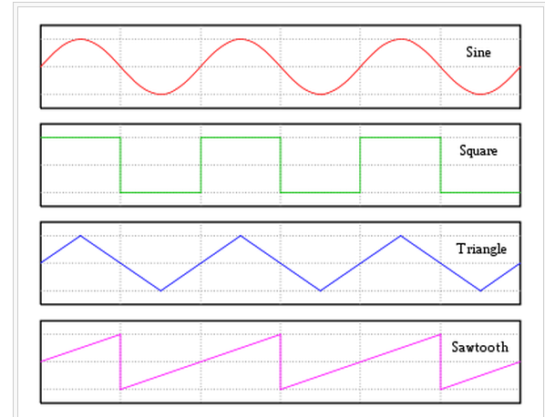

#### <**Sine**>

A single frequency, pure sounding tone.

#### <**Saw**>

Produces a harsh and clear sound, contains both even and odd harmonics of the fundamental frequency.

2.1.1.3 <**Square**>

A square wave is constructed from only odd harmonics

### <Cut-off filter>

This section allows you to select filter type and cutoff frequency.

2.1.2.1 <**Lowpass**>

Allows only frequencies up to a specific cutoff point to pass.

2.1.2.2 <**Highpass**>

Allows only frequencies past a specific cutoff point to pass.

2.1.2.3 <**Resonance**>

Adjusts the naturally occurring resonant peak of the filter.

* + 1. **<Midi Operation>**

Insert any MIDI 1.0 compliant device into USB port. Select device in drop down window. Play device.

* + 1. **<Setup and Installation>**

Unzip zipped packed click on SERQET.EXE file. Plug in any available midi device and enjoy.

**Guidelines**

**Setup and installation -** Unzip and click on executable file.

**Midi setup -** Connect any midi 1.0 compliant device into your computer usb port. Select device on device dropdown menu.

**Play notes** - Using the midi keyboard, computer keyboard, or on-screen keyboard, generate synth sound monophonically (one note at a time).

**Waveform selection** - turn waveform knob to desired waveform.

**Cutoff filter selection** - select desired cutoff filter adjust cutoff slide and resonance to taste.

**RID-001** The system **shall** accept input from any external MIDI compliant device, or the on-screen keyboard.

**RID-002** The system **shall** produce a note of the frequency corresponding to the MIDI note played.

**RID-003** The system **shall** accept one note at a time, with new input overriding the previous note played.

**RID-004** The system **shall** allow the user to select from 3 waveforms for the synthesizer.

**RID-005** The system **shall** allow 3 simultaneous waveforms, of varying types, to be mixed.

**RID-006** The system **shall**  have a cutoff filter, selectable from low or high pass, with cutoff frequency, resonance, and drive adjustable by the user

**RID-007** The system **shall** have a toggleable reverb effect, with an adjustable range for wet/dry mix, room size, and damping.

**RID-008** The system **shall** have a toggleable delay effect, with an adjustable range for wet/dry mix, feedback, and delay time.

**RID-009** The system **shall** run as a standalone application on a Windows operating system

Note: We know SERQET will have these features: Switching waveforms, switching filter types, adding reverb, including delay.

**Your system will be tested according to these requirements.**